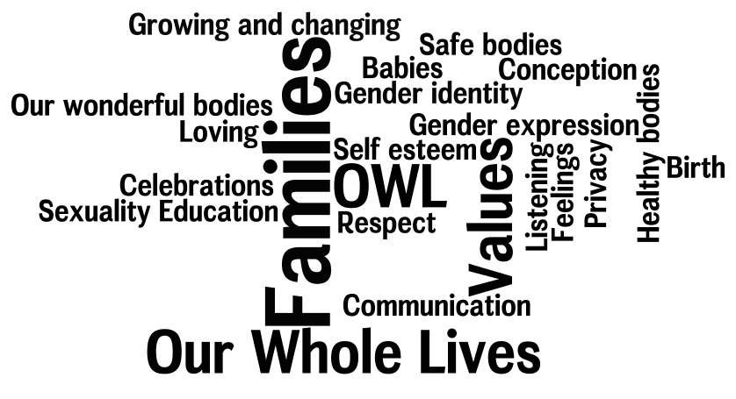
Our Whole Lives: Sexuality Education for Grades K-1, 2nd ed. can help educate children about bodies, boundaries, gender, families, babies and more. You will be actively involved as your child learns through songs, stories, activities and at-home projects that promote family dialogue.

Our Whole Lives: Sexuality Education for Grades K-1, 2nd ed.

OWL can help you educate your child about sexuality.
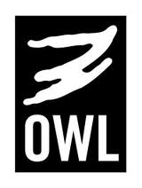
Our Whole Lives (OWL) values:
•Relationship
•Responsibility
•Respect

In eight, one-hour workshops, OWL models and teaches caring, compassion, respect, and justice. It helps young children identify their attitudes, values, and feelings about themselves, their sexuality, and others’ sexuality. Participants in Grades K-1 are guided by trained facilitators through an engaging curriculum that addresses age- appropriate topics. In addition to a parent meeting and a parent-child orientation, parents are welcome to attend any or all of the workshops with their children. Homelinks keep parent-child communication open.

OWL is a secular curriculum, appropriate for many settings.
Sexuality and Our Faith-inclusive versions of OWL with Unitarian Universalist and United Church of Christ material are also available.
For more information, contact OWL@UCC.org or OWL@UUA.org.

Workshops
Program Information Meeting
Parent/Caregiver and Child Orientation Program

1. Our Wonderful Bodies
2. Bodies and Gender
3. Body Boundaries
4. Families
5. How Babies Begin
6. Pregnancy and Birth
7. Babies
8. Celebrations!

Our Whole Lives: Sexuality Education for Grades K-1, 2nd ed.

